**Name: Khethelo Lungisani Shongwe**

**Student No: ST10442553**

**Module code: IMAD5112**

**INTRODUCTION**

The Age Comparison Android App is a prime example of utilizing mobile technology to transform traditional learning experiences, specifically within the domain of history education. This report provides a detailed examination of the app's purpose, design considerations, and the strategic implementation of GitHub and GitHub Actions in its development, underscoring the profound impact of mobile applications on contemporary educational paradigms. Introduction: In today's rapidly evolving technological landscape, the fusion of education and technology presents exciting opportunities for innovation.

The app's goal is

By providing students with an interesting and interactive platform to investigate the lives and legacies of well-known historical personalities, the Age Comparison Android App aims to revolutionize the teaching of history. In addition to providing users with accurate historical facts about historical personalities, age comparison encourages users to make personal connections and draw parallels between historical events and their own lives. The program aims to instil in its users a lifetime love of learning by encouraging curiosity, critical thinking, and a deeper respect for history.

The software attempts to bridge the gap between students' living experiences and historical events, a problem that is frequently encountered in history education. Users can see themselves reflected in the lives of historical individuals thanks to the app's individualized age comparisons, which build a bridge between the past and present. Users are inspired to learn more about the world around them and explore further into historical content by this individualized approach to learning, which creates a sense of relevance and engagement.

In addition, the app aims to democratize historical knowledge accessibility by making it available anywhere, at any time. Mobile applications provide unmatched flexibility and convenience in an increasingly digital world, enabling users to interact with instructional information on their own terms. The Age Comparison Android App offers a smooth and engaging learning experience that enables users to study history at their own speed whether they are in the classroom, at home, or on the go.

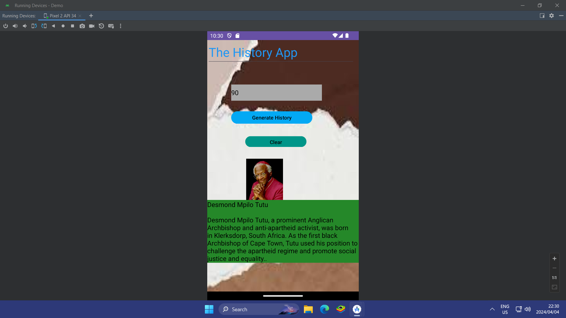

**Aspects of Design:**

A dedication to producing a visually appealing and user-centric experience is at the heart of the design concept of the Age Comparison Android App. With its history-themed images, pictures, and user-friendly navigation, the app's user interface (UI) is painstakingly designed to appeal to its target demographic of students. Through the use of visually attractive environments, the app seeks to draw users in and maintain their engagement with historical knowledge.

Users may easily explore the app and concentrate on the information without any interruptions because to the UI design's emphasis on simplicity and ease of use. The app's features are easily navigable and intuitive, making it simple for users to compare ages and discover historical people. Users are also drawn back for more because of the immersive and entertaining learning experience that is created by the use of vivid colors, captivating animations, and interactive components.

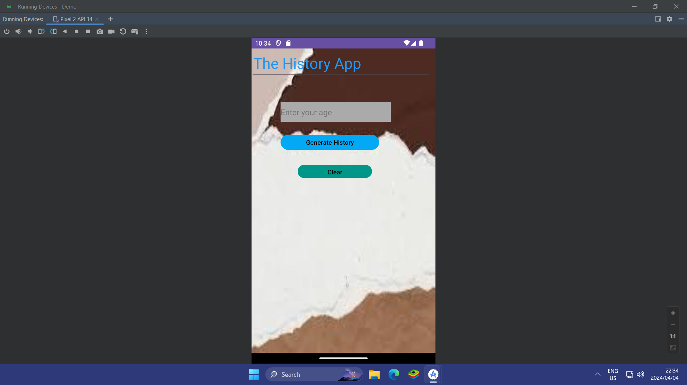

The app is inclusive and can accommodate a wide range of user needs in terms of accessibility. While auditory cues and alternate navigation choices accommodate users with hearing or mobility limitations, font sizes, colors, and contrast ratios are carefully chosen to assure readability for users with visual impairments. The software guarantees that all users, regardless of their abilities or constraints, can interact with historical content by giving accessibility first priority in its design.

Central to the functionality of the app is its age classification logic, which relies on a robust data structure to store information about famous historical figures and their ages at the time of passing away. This data is then leveraged to perform real-time comparisons with user-inputted ages, generating personalized results that resonate with users on a personal level. By employing efficient algorithms and logical processing, the app ensures accuracy and relevance in its output, thereby enriching users' understanding of historical contexts and figures.

The main component of the app's educational value is its age comparison tool, which enables users to better understand the passage of time and place themselves in historical context. The software encourages empathy, critical thinking, and a sense of historical consciousness in users by offering concrete parallels between the past and present. Users are encouraged to examine the varied fabric of human history and realize the connections between the past and present, whether by comparing their age to that of a well-known scientist, artist, or political figure.

To keep the user experience fluid, error handling systems must be effective. The Age Comparison Android App uses precise error messaging and strict input validation to help users navigate the app's features and resolve any possible problems. Through prompt feedback and assistance, the app enables users to confidently and easily traverse the learning process, resulting in a good and fulfilling educational experience.

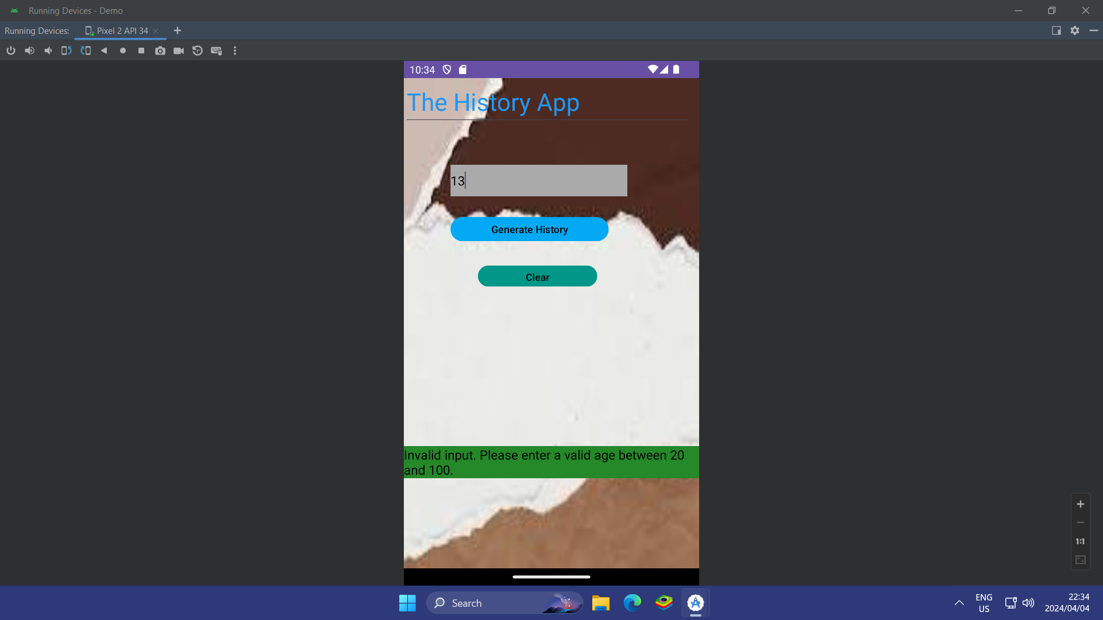

The error handling system is made to be both user-friendly and educational, offering precise instructions on how to fix typical mistakes and steer clear of dangers. For instance, a user receives a helpful error notice explaining the problem and providing solutions if they provide an incorrect age or format. In a similar vein, users are reminded to modify their input if their age is outside of the acceptable range for comparison. Through proactive error correction and successful outcome guidance, the app reduces user annoyance and fosters a positive learning environment.

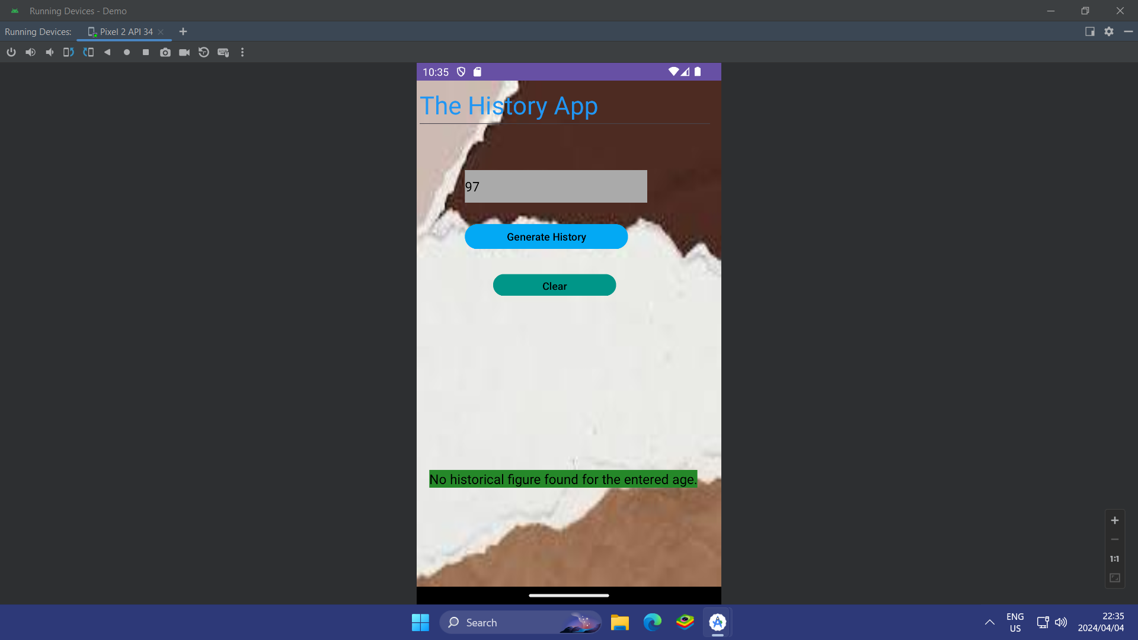

**GitHub and GitHub Actions Utilization:**

The Age Comparison Android App development team uses GitHub as the main platform for teamwork, version control, and project management. Team members may easily track changes to the code, participate in the project, and help with continuous communication by using a dedicated repository. Throughout the development lifecycle, stakeholders may keep an eye on developments and offer input thanks to regular pushes and commits to the repository, which guarantee accountability and transparency.

GitHub Actions automates building and testing, among other necessary processes, to further expedite the development process. Workflows for continuous integration (CI) are set up to run tests automatically as soon as code changes are committed to the repository, making it easier to identify and fix problems early on. The development team can minimize manual labour and shorten time-to-market by utilizing automation to assure the app's robustness and dependability.

Using GitHub and GitHub Actions facilitates an iterative and collaborative approach to app development, enabling team members to collaborate easily and produce high-calibre outcomes quickly. GitHub simplifies the development process and frees up the team to concentrate on creativity and innovation by centralizing project administration and automating tedious processes. Furthermore, the accountability and openness provided by GitHub facilitate efficient communication and teamwork, encouraging a sense of pride and responsibility among team members.

**In conclusion:**

Conclusively, the Age Comparison Android App is a noteworthy achievement in the development of history teaching, demonstrating the revolutionary capacity of mobile technology to enable captivating and participatory educational endeavours. The software provides students with an engaging platform to explore historical knowledge in a personalized and immersive way by emphasizing user participation, careful design, and seamless functionality. By utilizing GitHub and GitHub Actions strategically, the development process may be expedited to facilitate collaboration, ensure code quality, and eventually produce a product that enables users to set off on a voyage of exploration and enlightenment through the pages of history.